Chapter 10, Solution 63.

Obtain the Norton equivalent of the circuit depicted in Fig. 10.106 at terminals
a-b.

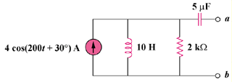

Figure 10.106
For Prob. 10.63.

Solution

Transform the circuit to the frequency domain.

is found using the circuit in Fig. (a).

Z_{N}

(a)

2 k

-j k

j2 k

1 kΩ
We find using the circuit in Fig. (b).

430 A

(b)

-j k

I_{N}

2 k

j2 k

By the current division principle,

Therefore,
I_{N} = 5.657∠75° A
1 k

